**Standard Operating Procedure on Prevention of Mother to Child Transmission (PMTCT) of HIV**

**Background**

A mother infected with HIV can transmit the virus to her child while pregnant, during delivery or through breastfeeding. This is called mother-to-child transmission (MTCT) or vertical transmission; while measures taken to forestall the transmission is called prevention of mother-to-child transmission. Without any interventions, 25-40% of children born to HIV infected mothers will become infected, accounting for most HIV infections in children.

Risk factors

|  |  |
| --- | --- |
| Maternal   * Low contraceptive use * High viral load during pregnancy, labour, delivery and breastfeeding. * Other infections (including STIs and malnutrition in the woman). * Haemorrhage (bleeding in pregnancy) * Fetal manipulations * Early rupture of membranes (>4hours before delivery) * Instrumental deliveries (use of forceps or vacuums; including episiotomy) | Infant   * Preterm birth. * First infant in multiple birth * Extended duration of breastfeeding. * Early mixed feeding * Oral diseases in the infant and breast diseases (abscesses, mastitis and nipple fissure).   Cross-cutting   * Areas with high HIV prevalence |

**PMTCT**

PMTCT includes a package of care given to women of reproductive age, pregnant women, their families, and communities to prevent the spread of HIV infection to children. Built on 4 pillars:

**Figure 1: the 4 pillars of PMTCT**

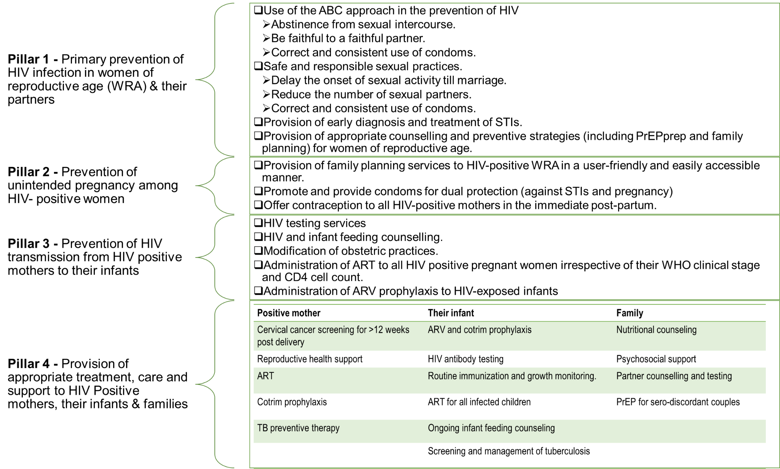

**Comprehensive Care and Treatment Services for the Mother-Baby Pair**

|  |
| --- |
| **Initial Evaluation of HIV positive pregnant woman**  Perform a full physical examination in addition to the routine ANC service. Emphasize on eliciting signs and symptoms of HIV-related illnesses.  Examine for: anaemia, persistent diarrhoea, respiratory infections (especially TB), candidiasis (oral and vaginal thrush), lymphadenopathy, vaginal warts and discharge, abnormal weight gain or loss |
| **Initial Clinical Evaluation of HIV positive pregnant woman**  The clinician should conduct a holistic assessment of the HIV positive pregnant woman to identify likely problems and/or complications of HIV or/and the pregnancy. The examination should be done respecting the client’s privacy and rights.  Special attention should be placed on signs of OIs such as: pallor, dehydration, thrush (oral, oesophageal and vaginal), abnormal chest findings, skin conditions, other STIs |
| **Laboratory Investigations for HIV positive pregnant women**  All HIV positive pregnant women should have all routine laboratory investigations carried out for all pregnant women. In addition, they should have the following specific investigations for HIV monitoring:   * CD4, Recency, TB LF_Lam, CrAg tests: at booking * Viral load: 3months after commencement of ART and at 32-36weeks GA |
| **ART in pregnancy**  All HIV positive pregnant women MUST be placed on ART. The preferred regimen for pregnant and breastfeeding women is TDF+3TC+DTG (TLD)  Alternate regimens include: TDF+3TC+EFV(TLE) or ABC+3TC+DTG |
| **Infant Prophylaxis**  All infants exposed to HIV should receive ARV prophylaxis. Infants with a low-risk of acquiring HIV should receive Nevirapine (NVP) once daily for 6weeks while high-risk infants should receive dual prophylaxis with Zidovudine (AZT) twice daily and Nevirapine (NVP) once daily for the first 12weeks of life irrespective of the feeding option (breastfeeding or formula-feeding).   |  |  |  |  |  |  |  |  |  |  |  |  |  |  |  |  |  |  |  |  |  |  |  |  |  |  |  |  |  |  |  |  |  |  |  |  |  | | --- | --- | --- | --- | --- | --- | --- | --- | --- | --- | --- | --- | --- | --- | --- | --- | --- | --- | --- | --- | --- | --- | --- | --- | --- | --- | --- | --- | --- | --- | --- | --- | --- | --- | --- | --- | --- | | High risk infants   1. Born to HIV-positive woman <4 weeks on ART as at the time of delivery. 2. Born to HIV-positive woman with viral load >1000copies/mL 4 weeks before delivery. 3. Born to HIV-positive woman with incident HIV infection during pregnancy (including women diagnosed in labour and breastfeeding). 4. Identified for the first time during the post-partum period (with or without a negative HIV-test result prenatally  |  |  | | --- | --- | | Infant Age | Daily dosing of NVP | | Birth to 6weeks  Birth weight <2.5kg  Birth weight =/>2.5kg | 10 mg (1ml) once daily  15 mg (1.5ml) once daily |   Table 1: ARV prophylaxis for low-risk infants   |  |  |  | | --- | --- | --- | | Infant Age | NVP daily dosing | AZT daily dosing | | Birth to 6weeks  Birth weight <2.5kg  Birth weight =/>2.5kg | 10 mg (1ml) once daily  15 mg (1.5ml) once daily | 10 mg (1ml) twice daily  15 mg (1.5ml) twice daily | | 6 weeks to 12 weeks | 20 mg (2ml) once daily | 60 mg (6ml) twice daily |   Table 2: ARV prophylaxis for high-risk infants  Cotrimoxazole Prophylaxis for HIV exposed Infants  It is recommended for all HIV exposed infants to receive cotrimoxazole (cotrim) from 6weeks of age till HIV infection has been excluded (using an age-appropriate HIV test) 8-12 weeks after complete cessation of breastfeeding.   |  |  | | --- | --- | | Infant Age or Weight | Dosage | | For infants below 6 months or < 5 kg | 120 mg daily | | For children 6 months – 5 years or 5-15 kg | 240 mg daily |   Table 3: Dosing for Cotrimoxazole Prophylaxis in HIV-exposed infants and HIV-infected children  **Infant feeding options in HIV context**  Infant feeding options is important in PMTCT as HIV can be transmitted to an infant through breastmilk and breastfeeding increases the risk of HIV transmission by 5-15% in the absence of any intervention. Breastmilk substitute has the benefit of no HIV transmission but has the risk of increased morbidity and mortality from malnutrition, diarrhoea and pneumonia.   |  | | --- | | Recommendation   * HIV exposed infants should be exclusively breastfed for the first 6 months of life. * Complementary feeds should be introduced at 6months and should adequately complement breastmilk. * Breastfeeding with complementary foods should continue till 12 months of age. |   **Early Infant Diagnosis**  All HIV-exposed infants should have a DNA PCR test:   |  |  | | --- | --- | | Breastfed infant | Not breastfed | | * Birth * 6-8 weeks * 9 months * 8 – 12 weeks after cessation of breastfeeding. | * Birth * 6 weeks |   Table 4: DNA PCR spacing  **Activities at 6weeks for a HEI**   |  |  |  | | --- | --- | --- | | Medications | Investigation | Others | | Stop ARV prophylaxis (except in high-risk infants) | Conduct 2nd PCR. | Ensure immunization according to schedule. | | Commence cotrimoxazole prophylaxis |  | Reinforce counseling on feeding options. | |  |  | Ensure adherence for mother-baby pair. |   Table 5: 6weeks appointment for HEI | |

**PMTCT/TB Integration Services**

**Pregnant women with HIV and TB co-infection**

Tuberculosis (TB) accounts for 1 in 3 HIV-related deaths and HIV-TB comorbidity in pregnancy causes up to 40% deaths in pregnancy. Continuous screening for TB in HIV-positive women is therefore mandatory and must be carried out throughout pregnancy to identify women with active TB disease for immediate access to TB treatment while those not infected be placed on TB preventive therapy (TPT) irrespective of the duration of the pregnancy.

* At every visit, the pregnant or breastfeeding HIV-positive woman should be screened for TB and offered the following services: s:

|  |  |
| --- | --- |
| Symptoms | Services rendered |
| No cough, but has other TB symptom | Refer to the medical officer to exclude TB. |
| Cough, with other symptoms of TB | GeneXpert test with subsequent preventive or treatment service |
| No TB symptoms | Counsel and start on TPT irrespective of gestation age of pregnancy |

|  |
| --- |
| **TPT involves administering medications for a period of 6months to persons without active TB to protect them from developing active TB.**  Isoniazid 300mg daily is commonly used.  Isoniazid + Cotrimoxazole + Pyridoxine is a good option for HIV-positive pregnant and breastfeeding women. |

**Management of Newborn and Mother/Household contacts with active TB**

|  |  |
| --- | --- |
| **Scenarios** | **Management** |
| Mother diagnosed with TB prior to 3rd trimester and on TB medications with good adherence and improving | * If the newborn has no signs of TB: administer BCG vaccine. * If the newborn has signs and symptoms of TB: evaluate further for TB. * If signs and symptoms of other illnesses: refer or manage appropriately. |
| Mother diagnosed with TB in the 3rd trimester or shortly after delivery: | * Defer BCG vaccine administration for the newborn. * Evaluate the infant for congenital TB if symptomatic or where mother is AFB positive or has untreated disseminated or partially treated TB or poor adherence. * If mother has endometrial TB, evaluate infant using Chest Xray, gastric aspirates for GeneXpert or abdominal ultrasound scan. * If TB is confirmed in the newborn, initiate TB therapy promptly in consultation with a paediatrician (where available). * Administer TPT if congenital TB or active TB is excluded. * If Mantoux/IGRA is negative and TB disease is excluded and mother/household contact becomes smear-negative, stop INH and administer BCG vaccine 2 weeks after stopping TPT. * Refer all household contacts for TB evaluation. |

Table 6: TPT summary

**TB Infection Control**

1. Separate newborn from any active case of TB in the household (including the mother) during the evaluation period.
2. Expressed breastmilk should be given to the infant during the period of isolation.
3. Mother and adult contacts should wear facemasks while handling the baby.
4. Once the baby is on TPT and the source of infection (mother or any other adult) is on continuation phase of treatment, there is no need for isolation and the infant can be breastfed.

**Special considerations for adolescents and young women in PMTCT**

The need for adolescents requires focus on the heightened physiological, emotional and social vulnerabilities.

Key concerns and considerations across the pillars are:

|  |  |  |
| --- | --- | --- |
| *Pillar* | *Concern* | *Consideration* |
| *Pillar 1* | *Low knowledge of HIV transmission.*  *Low-risk perception and awareness of prevention methods.*  *Late start of ANC.* | *Target AGYW at the community level in providing HIV prevention messages.*  *Consider provider-facilitated screening, peer-counselor, and self-assessment.* |
| *Pillar 2* | *High rate of unintended pregnancies.*  *Unsafe abortions.*  *Lack of knowledge and access to contraceptive options.*  *Non-friendly services.* | *Contraceptive information tailored to AGYW living with HIV.*  *Contraception and dual protection integrated into HIV care.*  *Adolescent support groups and community-based distribution of contraceptives.* |
| *Pillar 3* | *Late ANC start.*  *Delayed HIV testing and initiation leading to poor treatment options.* | *Tailored approaches to case finding, early testing and initiation for AGYW.*  *Facility- and community-based models specifically for young mothers.* |
| *Pillar 4* | *Continuity on treatment and post-EID treatment.*  *Child spacing.* | *Long-term care and support.*  *Integrated delivery of ART-SRH-FP.*  *Male-involvement and family-based care.* |

*Table 7: Adolescent concerns and considerations*

**Community PMTCT interventions (cPMTCT)**

According to NDHS 2018, 67% of pregnant women access ANC at least once, 39% deliver in a health facility, 43% by skilled birth attendants (SBA) and 57% by community or non-skilled attendants. Despite community ART interventions, PMTCT interventions have remained largely facility-based, leading to the poor reach for the latter. There was a need to scale-up PMTCT interventions to involve these community structures.

|  |  |  |  |
| --- | --- | --- | --- |
| Category | Description | Service provided | Data report |
| CAT 1 | Birth center owned by a retired health worker (CHEW at the minimum) | Routine ANC services.  Carry out basic lab tests.  Provide ART services. | Data should go to mapped hub sites weekly.  Support referral systems. |
| CAT 2 | Traditional birth center owned by non-healthcare worker. | Routine ANC services.  Determine danger signs in pregnancy and take deliveries. | Data should go to mapped hub sites weekly.  Support referral systems. |
| CAT 3 | Congregational approach. Places that reach out to groups of pregnant women, their HEIs and male partners. | Should have a lay priest or IMAM that prays for a group of pregnant women.  Have health assistants or support groups from the health facility.  Ensure referrals for newly identified PLHIV for ART initiation. | Data should go to mapped hub sites weekly.  Support referral systems. |
| CAT 4 | Delivery homes | Determine danger sign during labour and take deliveries. | Data should go to mapped hub sites weekly.  Support referral systems. |
| CAT 5 | Unsupported (spoke) health facilities | Routine ANC services.  Carry out basic lab tests.  Provide ART services. | Data should go to mapped hub sites weekly.  Support referral systems. |

Table 9: community PMTCT categories

**Package of Care for cPMTCT**

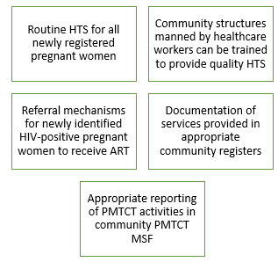

**Documentation flow and tools**

There are various stages in the PMTCT cascade and at various point, different tools are used for documenting service provision as seen below

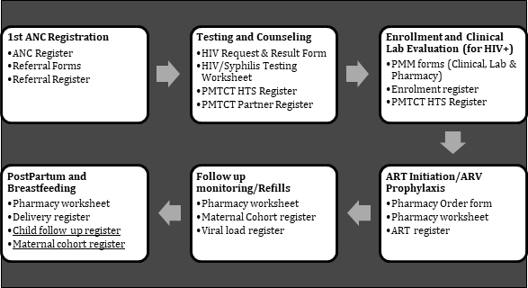

* At first ANC visit, ANC registration is documented in the General ANC register
* There is a need for all pregnant women to know their HIV status hence, registered pregnant women are referred for HTS using the referral form and documented in the referral register.
* Upon provision of HTS, the request and result form as well as the HIV/syphilis testing worksheet are filled.
* The HIV status of pregnant women is documented in the PMTCT HTS register (inclusive of previously known positives).
* Partners of all pregnant women should be tested and documented on the partner register.
* All positive pregnant women should be entered in the maternal cohort register and viral load sample collected at 32-36 weeks gestational age and documented on the viral load register, maternal cohort register and the EMR. Mother’s refills will also be updated on the maternal cohort register
* Upon delivery by a positive pregnant woman, the delivery register should be updated as well as the ART care card
* All live births by positive pregnant women should be documented in the child follow-up register for follow-up (EID, ARV Prophylaxis and final outcome).
* ACE 5 Daily Performance Tracker (document daily on the PMTCT section)
* National PMTCT Monthly Summary Form (MSF) - Monthly documentation in the DHIS MSF
* Electronic Medical Records (EMR) – LAMIS: Document daily into the PMTCT module on the EMR (LAMIS).